**30th – 31st Aug 2024**

**Updated 5th September 2024**

**JN**

A quick test with the copper tube grips showed that I personally could feel no sensation when the Resonator was active.

**Electrical tests**

**No load / open circuit**

Oscilloscope trace without load applied to the output (i.e. copper tubes not held, no other load applied.)

(The noise on horizontal sections is almost certainly due to the scope.)

Output from resonator into an open circuit is a roughly square wave at ~30kHz, min 0V and max 9V.

**Resistive load**

Connecting a 1kΩ resistor across the tubes (crudely simulating a body load) reduced the voltage measured to around 4.3V, suggesting a source resistance in the ‘high’ output state (i.e. 9V) of approximately 1kΩ. (A similar test with a 10 kΩ load gave a similar estimate of source resistance.) The waveform was otherwise not significantly changed.

**Reactive load**  
Any reactive component (capacitive / inductive) would not be so easy for me to estimate, however measurement with one pipes held in each of my hands gave the following waveform:

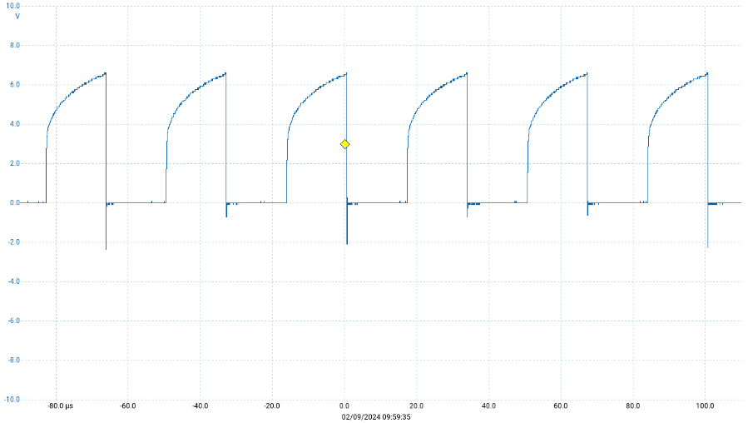

The shape of the leading edge of the waveform hints that my body may be presenting a load with a capacitive component which the device is unable to overcome before the falling edge of the waveform. The rapid fall suggests that the device’s impedance in the ‘low’ state is significantly less than the estimated 1kΩ. However these aspects of the waveform should not be over-interpreted; the devices used in the Resonator are likely to be highly non-linear, with the non-linearities determining the waveform as much as, or more than, the nature of the load my body presents.

(Adjusting my grip, unsurprisingly, had a significant effect on this waveform, with a firmer, larger area grip leading to a slower rise and lower maximum voltage.)

**Current delivered**

A resistance of 100Ω was inserted in series with the ‘low’ Resonator output (the negative side) during further measurement of the output when the copper pipes were held in the hands as above. Whilst this increase in total resistance would clearly have some impact on the current driven through the body, the impact will broadly be of the order of the ratio between the 100Ω added resistance and the estimated 1kΩ source resistance.

This gave the following result:

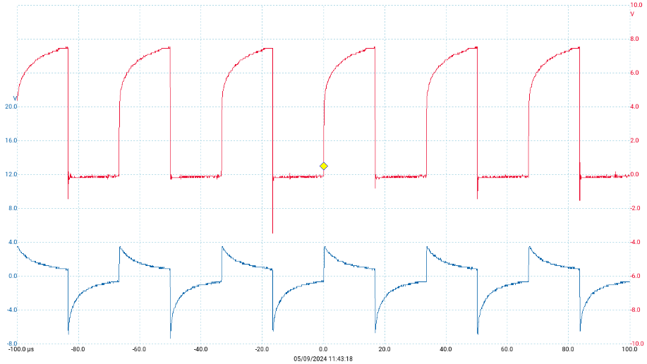

The red trace (and axis) is the voltage across copper pipes, a very similar waveform to the earlier test; any differences will be due to the added resistor (~10% higher resistance load presented to the Resonator as above) or subtly different grip / body properties.

The blue trace is the simultaneous voltage across the 100Ω resistor, which indicates the current flowing through it (and my body). It can be seen that this reaches a positive maximum of approaching 4V (corresponding to 40mA) as the Resonator starts the pulse, which decays to around 1V (10mA) by the end of the pulse. When the Resonator then reduces its output to around 0V a short negative spike of between 6 and 7V is evident across the 100 Ω resistor (i.e. 60-70mA current in the opposite direction) again decaying through the pulse.

As above, the mechanism determining these voltage/current patterns will involve both the load presented by my body and the internals of the Resonator.

**Case opening**

Large semiconductor device mounted on a single board with switches labelled as DUTY (cycle) and FREQ(uency).

Appears to be a commercially made device, display shows current settings but not visible externally. Chip itself is not identifiable without physically removing it from the board, board is glued-in. I would guess that it is a programmable microcontroller (or perhaps a device more specifically-focused on waveform generation) with a built-in display.

However a Google search shows this very nearly identical product:



<https://www.aliexpress.com/item/1005004379353896.html>

Price appears to be £1.26 for this model.

See also:

<https://www.ebay.co.uk/itm/163990626602?mkcid=16&mkevt=1&mkrid=711-127632-2357-0&ssspo=xnFdo6oTQmi&sssrc=4429486&ssuid=m4kH8e8XSzi&var=&widget_ver=artemis&media=COPY>

… seems to be widely available.

Unsurprisingly I have found no indication of any medical claims related to these devices or boards.